Al Muntaha Amuse Bouche Rotation

Week 1
Pressed Mirin Watermelon, Persian Feta cheese
Baby Green, Pomelo with Balsamico reduction
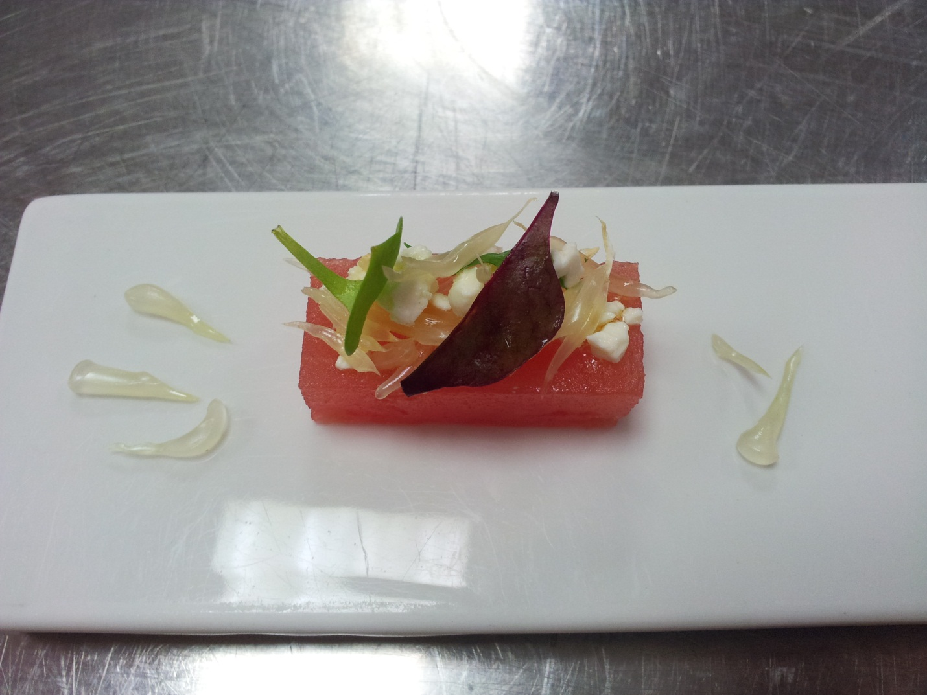

Method:
Slice in large band the watermelon and place in a vaccum bag with mirin, then seal 100% in the machine. Leave in the fridge overnight. On the day slice the rectangular size and on the top add the feta cheese mixed with a little olive oil, place the pomelo on the top with the decoration

Week 2
Choux Pastry stuffed Mascapone
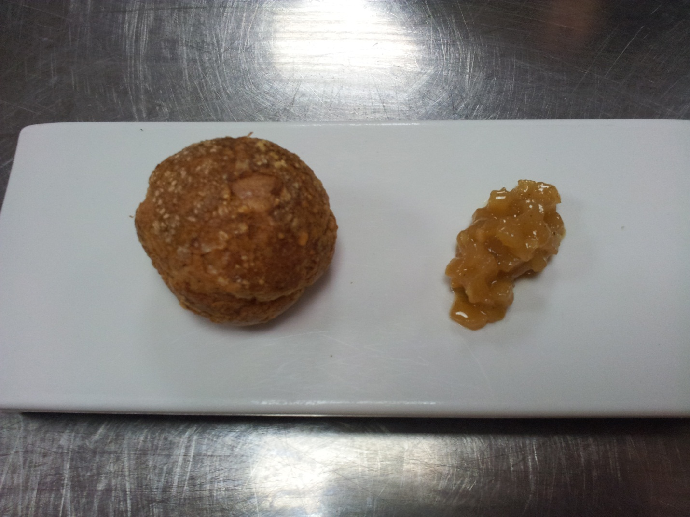
Pear Chutney

Method:
Make the little choux and stuffe with Mascarpone cream
On the side is a chutney of pear

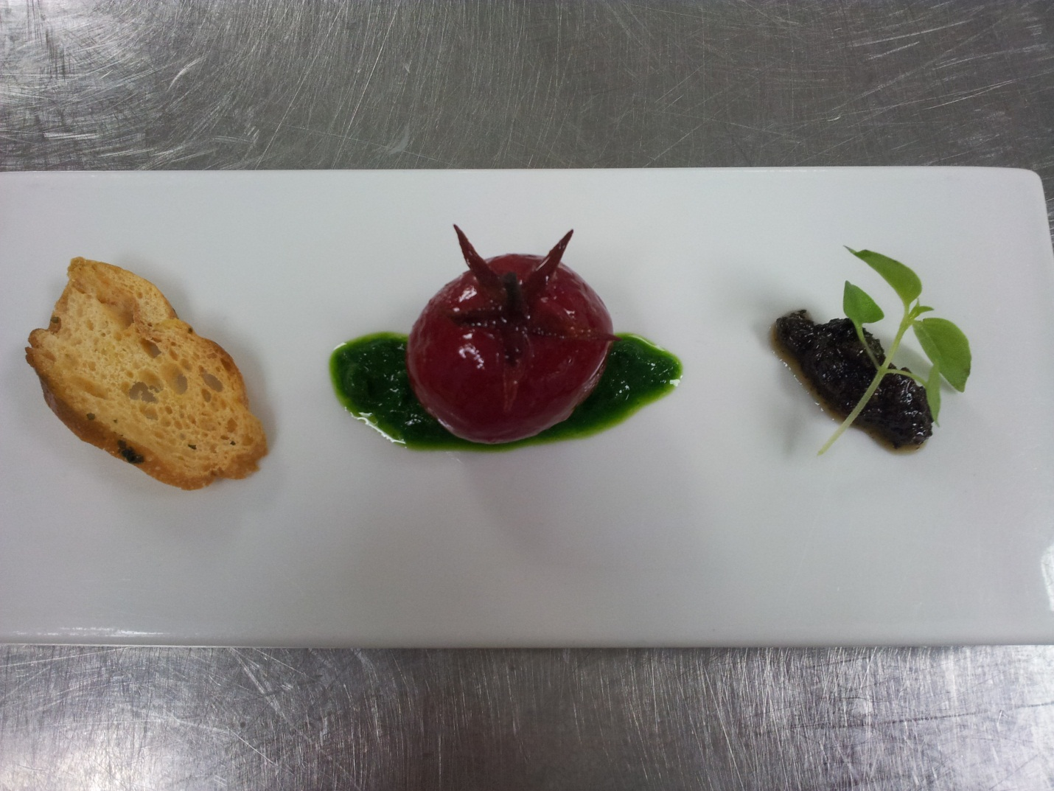
Week 3
Raspberry Tomato with Olive Tapenade, Parsley Puree and bread crouton

Method:
Peel off the skin of the baby cherry tomato and place them in a raspberry BOIRON puree for 24h.
Slice the crouton of baguette ot ciabbatta bread and toast
In the middle place the parsley coulis and the tomato on the top
On the right is the olive tapenade and the cress for deco

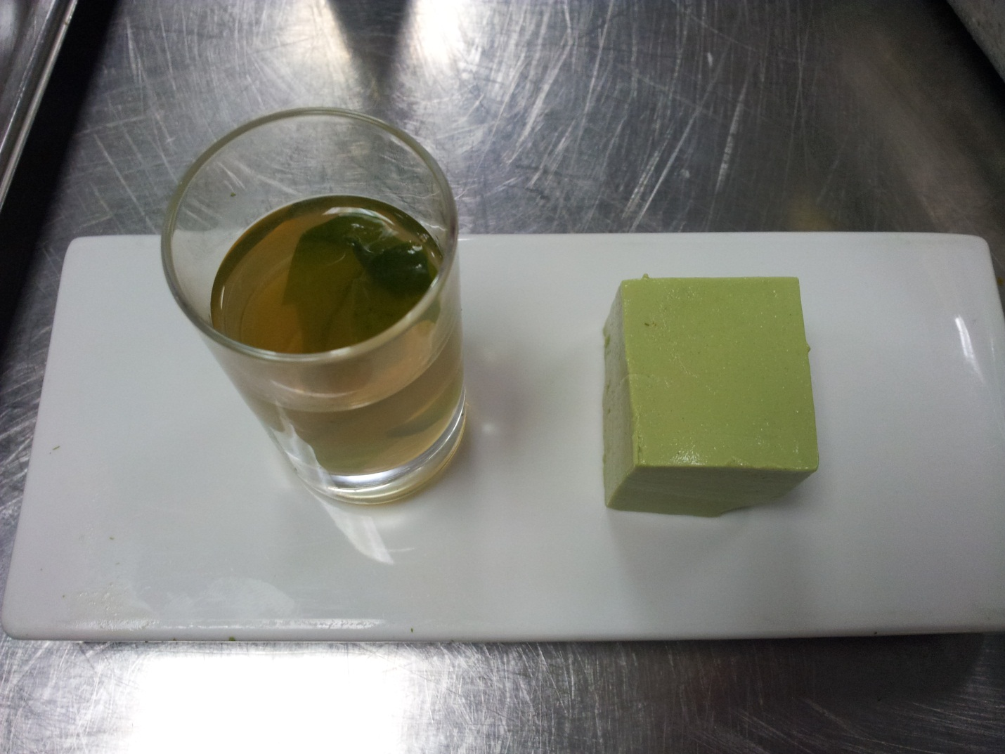
Week 4
Green Tea Tofu with Bonito Broth shooter
(The tofu has to be ROUND)
Method:
On the left is a bonito flake and water shooter and inside is a seaweed leaf
On the right is a green tea tofu (THE SHAPE NEEDS TO BE ROUND)

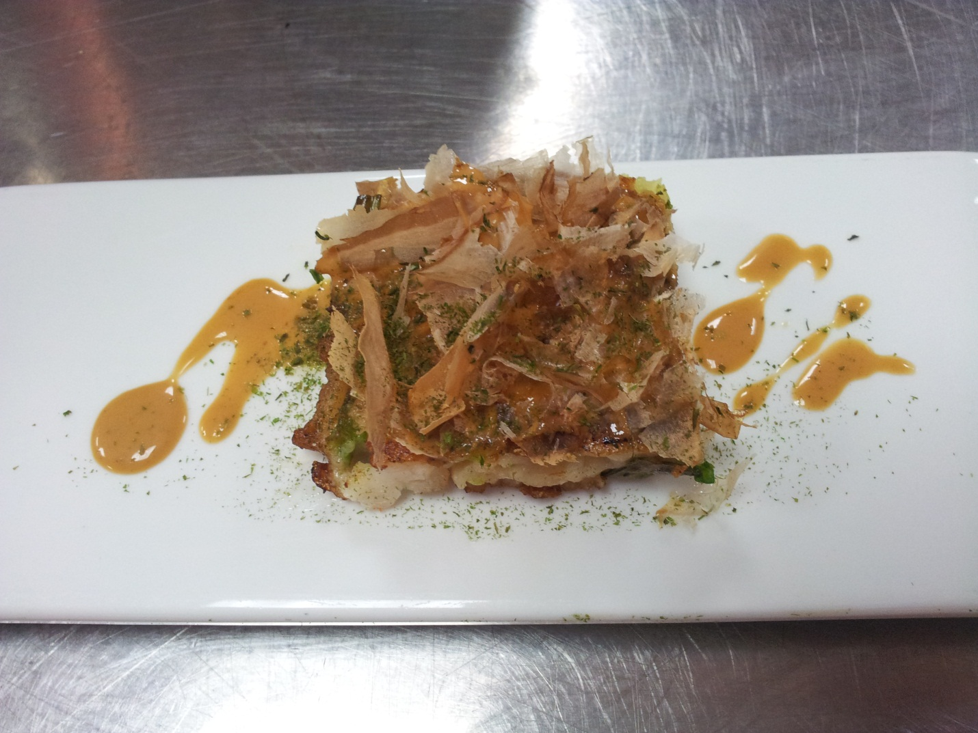
Week 5
Seafood Pancake on Hoisin Cream with bonito flakes

Method:
Pancake: Spring Onion and Squid Mix with Water, All Purpose Flour and seasoning with Sesame Oil, Salt and White Pepper. Place the Pancake in the Hot Pan and cook until Golden Brown Colour for both Side.
Sauce: Mayonaise + Hoisin Sauce + Lemon Juice
Garnish: Seaweed Powder and Bonito Flakes

